The hosting of a backend can either be done by buying servers, networking & security equipment & cisco routers, then hosting them in a hosting environment. This generally requires an IT team. However, there is a much better solution… **Cloud Computing**. Cloud computing reduces costs while enabling greater business agility and flexibility:

* **Reduced costs**. Cloud computing enables organizations to pay only for what they use. Instead of standing up dedicated infrastructure to run each application, you spin up virtual machines (VMs) on infrastructure owned and managed by a provider. You pay for the time you use the VMs, instead of setting up servers on your own infrastructure. In addition, your computing costs in the cloud are usually operational expenses paid monthly rather than hefty up-front capital expenses.
* **Greater business agility**. Agility is really about responsiveness. Cloud computing lets you respond quickly to business opportunities and threats. With physical infrastructure, scaling (up or down) is often a lengthy process that starts with requisition, justification to senior management, and purchase, followed by waiting for delivery, and then managing deployment, testing, re-configuration, and, finally, production.
* **Flexibility**. Flexibility gives you choice. With the cloud, you can instantiate or destroy VM instances as you need to, move workloads around, and change your mind and revert—without wasting already purchased resources. You can move, resize, consolidate, and make choices to optimize any business metric.

**Definitions**

**Infrastructure as a Service (IaaS)** is a form of cloud computing that provides virtualized computing resources over the Internet. IaaS is one of three main categories of cloud computing services, alongside **Software as a Service (SaaS)** and **Platform as a Service (PaaS)**

**Google Cloud Platform vs. Amazon Web Services**

There are a multitude of cloud computing/IaaS services, but you won’t find two more renowned and respected providers than Google (**Google Cloud Platform - GCP**) and Amazon (**Amazon Web Services - AWS**). We shall compare the relevant providers below:

1. Some basic differences:

* GCP tends to have an advantage in storage and network performance.
* AWS has an advantage in cloud features & points of presence worldwide.

1. Google’s cost structure is simple and straightforward. AWS’ is not.

* A key feature of GCP pricing is that there is only one method—you pay monthly for on-demand usage of virtual machine instances. The minimum is ten minutes, and usage is rounded up to the nearest minute. In addition, Google has publicly committed to passing along to customers any future price reductions Google achieves through technology-driven advancements in density, scale, power, and cooling. What Google provides is on-demand, real-time pricing.
* In contrast, AWS offers several pricing options. It offers on-demand usage pricing that is rounded up to the nearest hour, and this is Amazon’s most expensive pricing. Another option is called a Reserved Instance, where you make a commitment for either one year or three years for a specific VM instance. These come with payment options: to pay in full up front, to pay a portion of the cost up front, or to pay nothing up front. AWS’ lowest prices come from paying all of the cost up front.

1. Amazon has significantly more services than any other cloud provider.
2. AWS accounted for 37% of the $9 billion infrastructure as a service (IaaS) market in 2013, according to analysts from equity research firm Evercore. The IaaS market is growing by 45%, but Amazon Web Services has a growth rate of 60%.
3. AWS also has more than five times the computational capacity of its 14 next IaaS competitors combined, according to a Gartner report published last fall.
4. Google beats AWS on its IaaS computing platform, the most important service for both.
5. Another huge advantage of Google Compute Engine is that its Load Balancers don’t need any pre-warming. GCE balancers can scale instantly as soon as they notice a sudden traffic spike.

**Service Comparison**

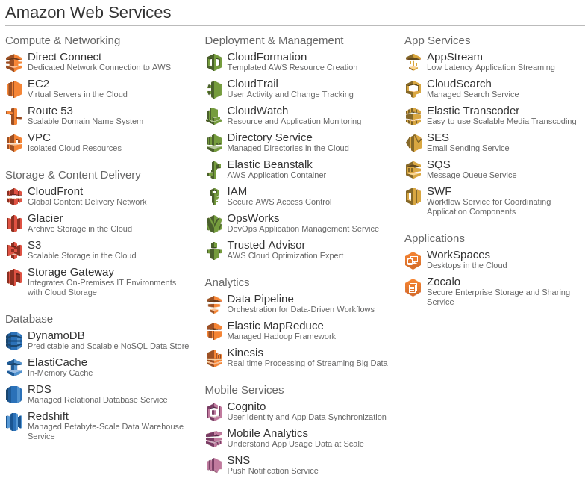

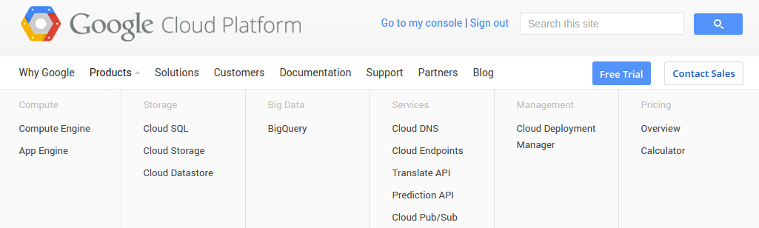

**Pricing Comparison**

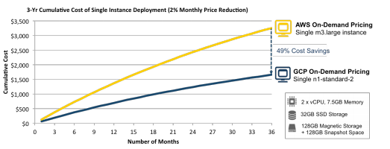

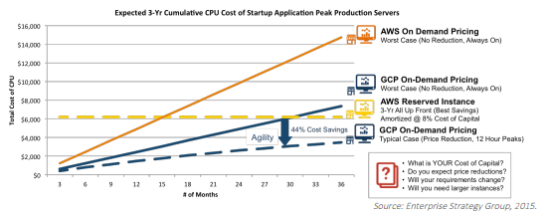

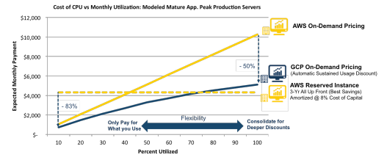

A more detailed comparison of pricing can be found at:

<https://cloud.google.com/files/esg-whitepaper.pdf>

**Example Starting Configuration**

Depending on the actual backend that you finally choose, I would recommend the **Google Cloud Platform paid every quarter.**

1. Cost of roughly **$805.00** **per quarter** (**possibly going up to roughly $1,200** **per quarter** after additional service needs are identified during development phase)
2. Initially 2 servers (1 database server & 1 system server /1 development server & 1 production server), 2 CPUs, 7.5GB RAM, 15GB CentOS Linux Server, hosted in USA, 375GB SSD for data storage

